# Prototype Report

**Hangry Mobile Food Truck Locator**

**NEON**

**Team Members and Roles**

John Humlick ------------------------------------------------ Architect

Amir Radman ----------------------------------------------- Project Manager/UI Designer

Aaron Escoto ------------------------------------------------ UI Designer

Daniel Tam ------------------------------------------------ Back-End Engineer

Natalia Zarubin --------------------------------------------- Back-End Engineer

# Version History

|  |  |  |  |  |  |  |  |  |
| --- | --- | --- | --- | --- | --- | --- | --- | --- |
| **Date** | | **Author** | | **Version** | | **Changes made** | | **Rationale** |
| 02/01/17 | John Humlick | | 1.0 | | * First version of the document | | * CS161 Prototype version1 | |
| 02/11/17 | | Aaron Escoto | | 1.1 | | * UI updated in the 2nd version of the document | | * UI work |
| 02/21/17 | | Natalia Zarubin | |  | | * Architecture enhancements | | * Architecture update |
| 02/27/17 | | Natalia Zarubin | |  | | * DB enhancements | | * DB update |
| 02/27/17 | | Daniel Tam | |  | | * Backend design enhancements | | * GPS Location |
| 02/28/17 | | Amir Radman | |  | | * UI updated in the 3nd version of the document | | * UI for Drivers |
| 03/01/17 | | Daniel Tam | |  | | * Backend design enhancements | | * GPS Location |

# Table of Contents

1 Prototype Report 1

Version History 2

Table of Contents 3

Table of Tables 4

1 Table of Figures 5

1. Introduction 6

2. Navigation Flow 6

3. Prototype 7

# Table of Tables

1 Prototype Report 1

Version History 2

Table of Contents 3

Table of Tables 4

1 Table of Figures 5

1. Introduction 6

2. Navigation Flow 6

3. Prototype 7

# Table of Figures

Prototype Report 1

Version History 2

Table of Contents 3

Table of Tables 4

Table of Figures 5

21. Introduction 6

22. Navigation Flow 6

23. Prototype 7

### Introduction

The purpose of this document is to create a prototype of our Hangry Mobile application to demonstrate the intended functionality.

### Navigation Flow

**Welcome Animation Pattern**: Welcome Animation is a prominent feature of HangryMobile application. How it works: a customer first opens the app, a full screen animation clip plays to welcome the customer and show off the brand.

**Login:** Neon team taking into consideration the fact that long sign up screens detract from the key mobile use case: quick, simple information access on the go. Overly invasive sign-up/sign-in screens presented upfront and without due cause can cause customers to delete the app

**Truck Owner Section:** the following functions will be available to the owner: enable GPS, disable GPS, Update Menu, Update Prices, display current menu, view ratings, exit the app.

**Customer Section:** the following functions will be available to the customer: view list of all GPS tracked trucks, view menu, find truck on the Google map, view menu and prices, view ratings, view truck profile, exit the app.

Navigation Flow Diagram.png

**Figure 1: Navigation Flow of Hangry Mobile**

### Prototype

The HangryMobile Truck application will implement Android GPS APIs, Google Map API v3, WebViews APIs with Android Home Server, AWS such as DynamoDB. The application will allow Food truck drivers to broadcast their geospatial location, while Food Trucks customers will be capable to locate the Food Trucks by using Android Google Maps.

Drivers will be able to update their menus and prices while customers will be able to view truks’ menus, prices as well as ratings. GUI will be simple and user friendly. Welcome Animation is a prominent feature of HangryMobile application. How it works: a customer first opens the app, a full screen animation clip plays to welcome the customer and show off the brand.

Neon team taking into consideration the fact that long sign up screens detract from the key mobile use case: quick, simple information access on the go.

The app user will be able to select his role as a customer or truck driver. The user could exit application at any time. While GPS broadcast, if enabled, will continue to run in the background thread.

**Table 1: Food truck owner screen**

|  |  |
| --- | --- |
| **Screen** | **Screen Description** |
| Welcome Animation | Welcome Animation is a prominent feature of HangryMobile application. How it works: a customer first opens the app, a full screen animation clip plays to welcome the customer and show off the brand. |
| Login Screen | Neon team taking into consideration the fact that long sign up screens detract from the key mobile use case: quick, simple information access on the go. |
| Selection screen | User selects its role |
| Mobile Truck Owner | A mobile food truck owner has opened the app. |
| Enable GPS | A mobile food truck owner selects to enable GPS Broadcast |
| Post condition-1 | Green button turns on indicating enabled GPS Broadcast |
| Post condition-2 | The location of the truck will be updated in AWS Database |
| Disable GPS | A mobile food truck owner select to disnable GPS Broadcast |
| Post condition | The location of the truck will be removed from AWS DB |
| Update Menu | A mobile food truck owner selects to update Menu/Price by selectin the Menu button |
| Post condition-1 | The Menu/Prices of the truck’s food will be updated in AWS Database |
| Post condition | The location of the truck will be stored on AWS depending on whether the operator clicks enable or disable. |
| Exit | A mobile food truck owner exits the app, while GPS remains running in the background |

|  |  |
| --- | --- |
| FoodTruck-UI.PNG | FoodTruck-UI2.PNG |

**Figure 2: Mobile Food Truck Owner app screen**

The following is a description of what customer can do with the HangryMobile app.

**Table 2: Customer home screen**

|  |  |
| --- | --- |
| Description | This image shows the customer interface shown when a user opens the app. |
| Welcome Animation | Welcome Animation is a prominent feature of HangryMobile application. How it works: a customer first opens the app, a full screen animation clip plays to welcome the customer and show off the brand. |
| Login Screen | Neon team taking into consideration the fact that long sign up screens detract from the key mobile use case: quick, simple information access on the go. |
| Post condition-1 | All nearby food trucks are drawn on a Google map. |
| Post condition-2 | List of all trucks is shown in the List View under the map |
| View Ratings | A mobile food customer click on the button located in the same view row as the truck and views the truck ratings, menu and relevant information |
| Exit | A mobile food customer exits the app |

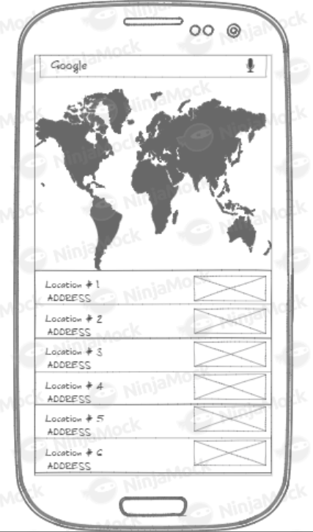

**Figure 3: Customer home UI screen**